**Report**

Assignment4 – Airliners

Team: Thursday

Lihang Zhou 001302072 & Qianyi Zhang 001059319 & Jieying Chen 001398614

* **Structure**

We create 4 packages which are business, interfaces, users and util respectively.

1. Business part: Business package mainly stores information and lists of administrator, airplane, airliner, flight and customer.

Including and detailed functions:

1. AdminList: stores all information of administrators which is created by users or default values.
2. Aircraft: stores information of airplanes, such as model, model number and belonging to which airline.
3. AircraftList: stores all information of airplanes which is created by airliners.
4. AirlinerList: stores all information of airlines which is created by airliners.
5. Business: stores several default values such as account of administrator, customer, airliner.
6. CustomerList: stores all information of airplanes which is created by customer.
7. Flight: stores all [variable](javascript:;)s about an airplane such as seats number, belonging airline, plane model, flight number, flight date, departure time, departure city, arrival city, ticket price and so on.
8. FlightDirectory: stores all information of flights which is created by airliners.
9. Traveler: stores all information of travelers which is created by customer or administrator.
10. Interfaces part: Interfaces package mainly shows several interfaces by panels, running functions between administrator, customer and airliner.
11. AddAircraftPanel: this panel shows aircrafts information which is created by airliners.
12. AddViewEditPersonOnBoardPanel: edit traveler’s information and save.
13. CreateFlightsPanel: airliners can create a new flight including information of flight number, departure and arrival city, take off time, landing time, and ticket price.
14. DisplayAllPanel: this panel shows all flights’ information of a specific airline by searching.
15. LoginPanel: this panel offers three identities for users to login in.
16. MainFrame: main frame panel shows three initial functions by login, sign up and exit button.
17. MainMenuPanel: shows 6 functional buttons which used by different identities. For example, “my profile” is used by customers to edit their personal information, “show all flights” is used by administrators to check all flights of a single airline, “manage aircrafts” is used by airliners to add or delete a flight, “username & password” is used by all users to change their password or name, “search & book a flight” is used by administrators and customers to book a flight, “manage my flight” is used by administrators and customers to add or delete a booked flight.
18. ManageAirCraftPanel: create, delete and update flight information.
19. MyProfilePanel: edit first name and Last name of users’.
20. MyUsernamePswdPanel: change username and password.
21. SearchFlightPanel: search flight information in detail, including departure date and time, departure and arrival city, airliner, and price.
22. UserCreatePanel: sign up a new user.
23. ViewFlightPanel: view a flight details.
24. Users part: Users package stores information of three identities which are administrator, airliner and customer respectively. All these three identities extends user’s function.
25. Admin
26. Airliner
27. Customer
28. User
29. Util part: Util package stores some button functions and validators.

* **Functions**

1. Sign up for a new user, you can choose as an airliner or a customer.

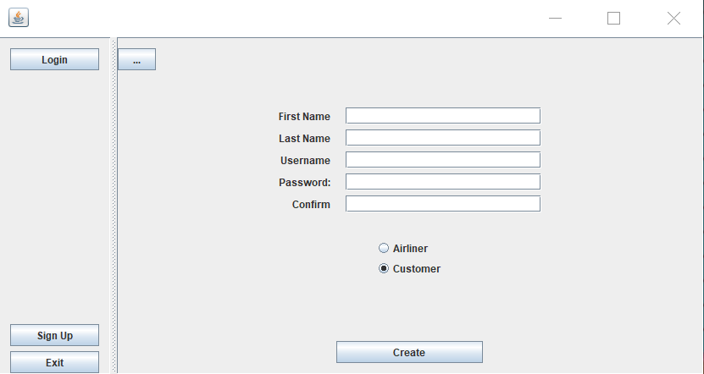

1. ① As an airliner:

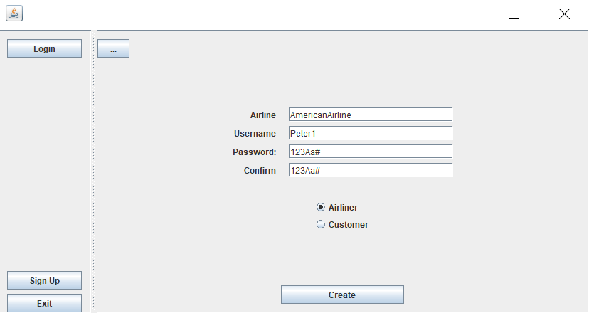

Validation is used.

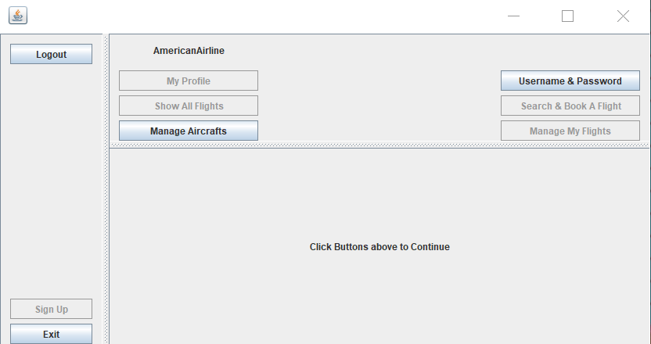

As an airliner, you can manage aircrafts of your airline and change your username and password.

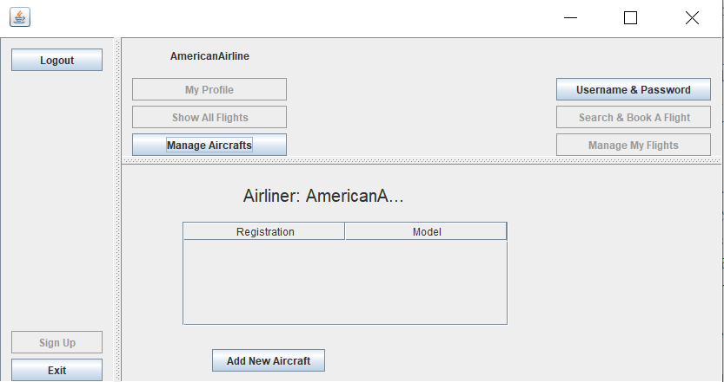

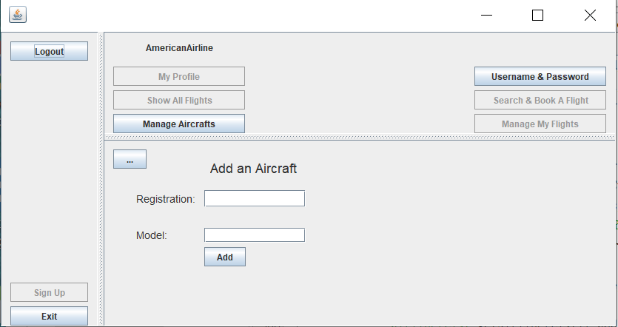

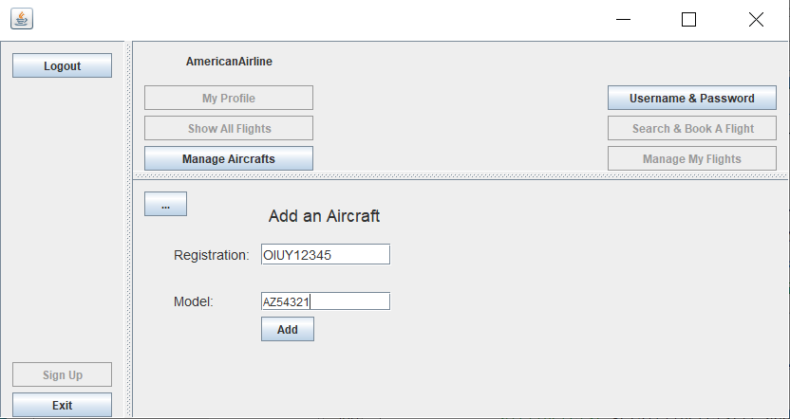

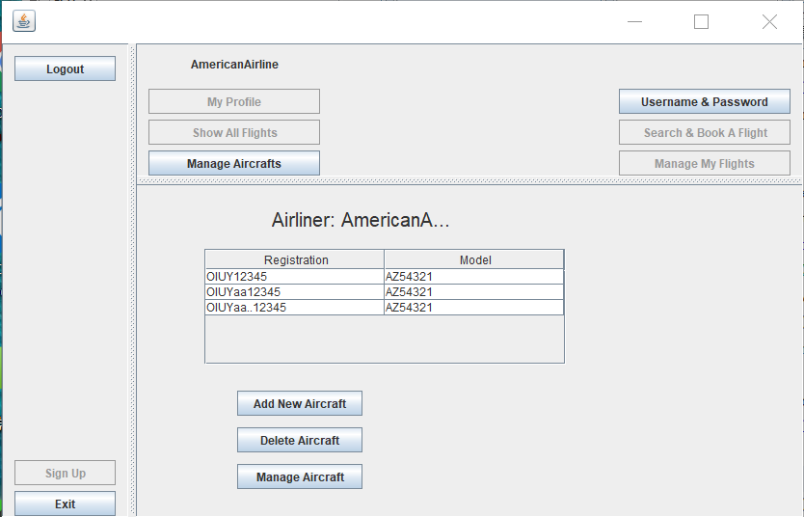

Added three airliners, no validation.

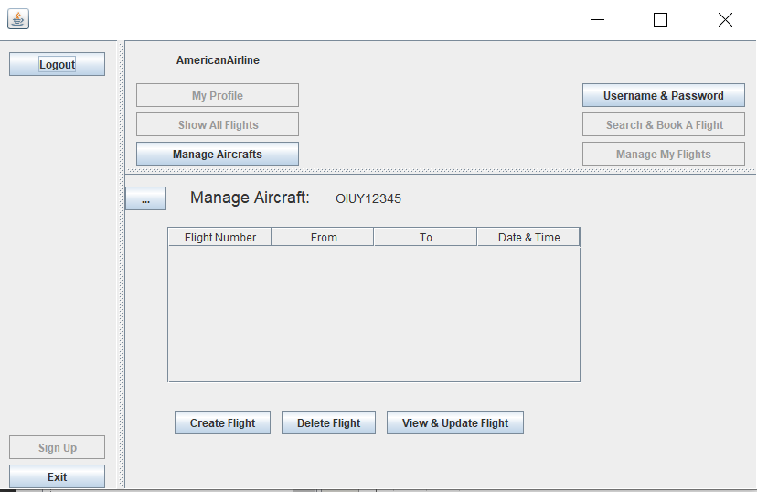

You can select one aircraft, and manage its flight information.

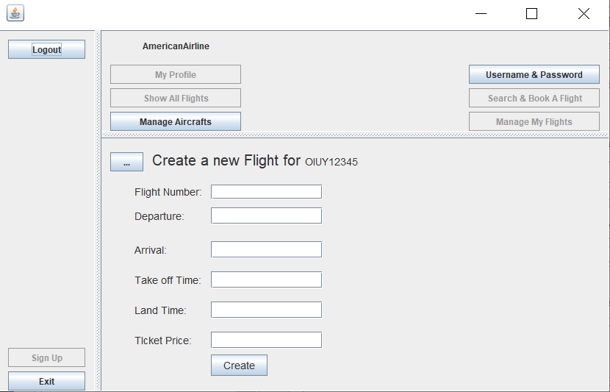

Airliners can create a new flight with detailed information.

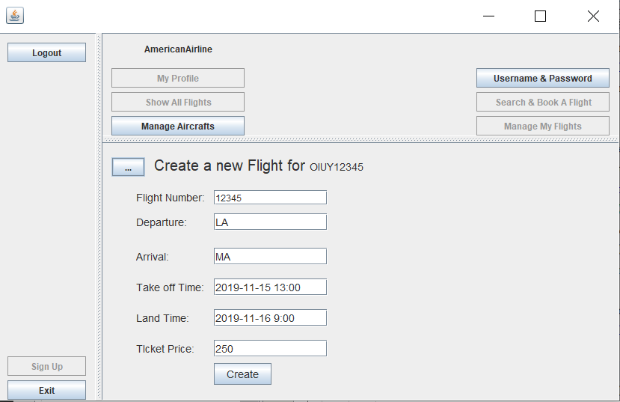

Validation is used, and you can not add a take off time before today’s current time, and land time can not before take off time.

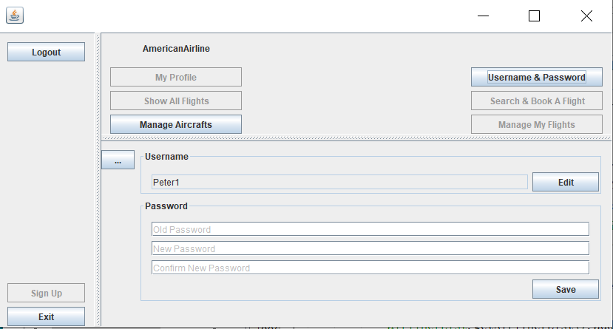

You can edit your username and change your password.

② As a customer:

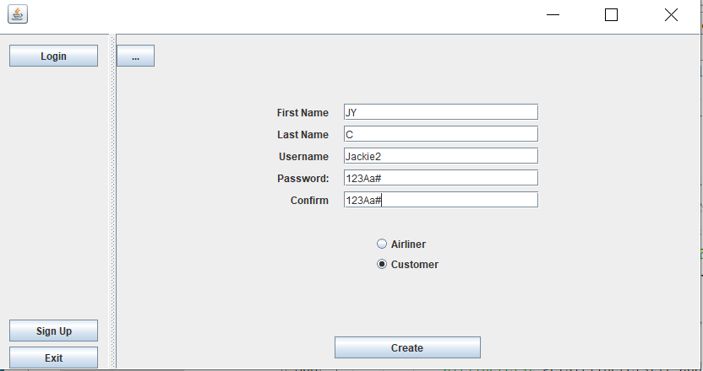

Create an account by first name, last name, user name and password.

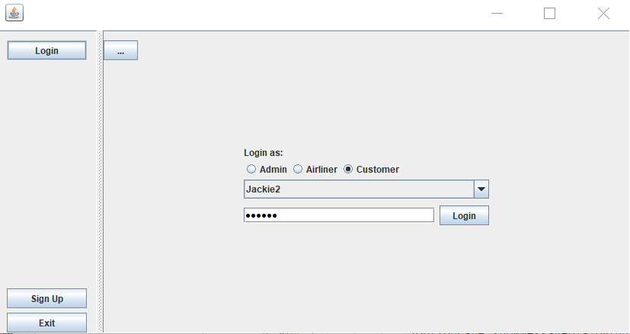

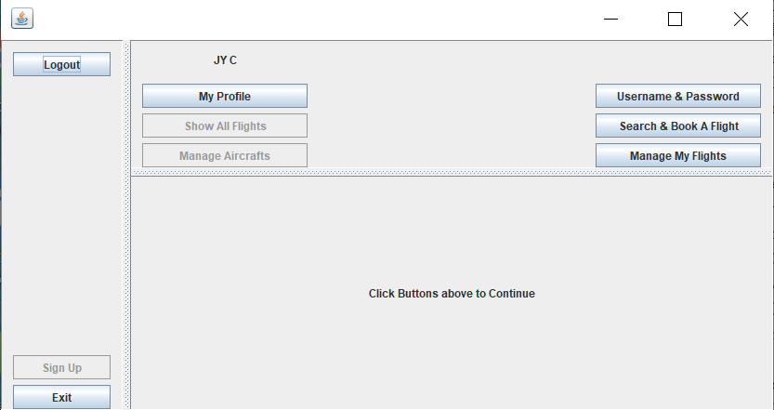

As a customer, you can edit your profile, change your username and password, search and book a flight, and add or delete your flights.

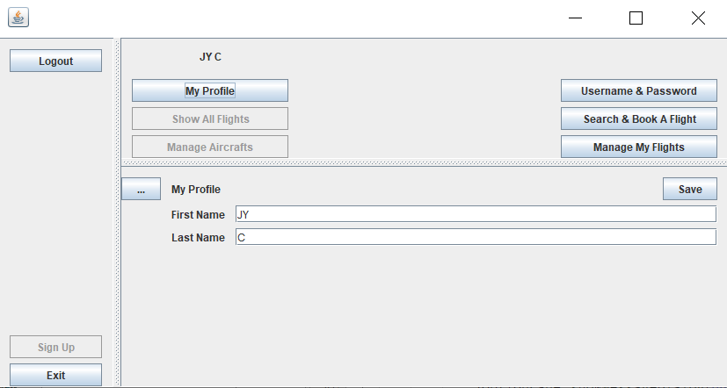

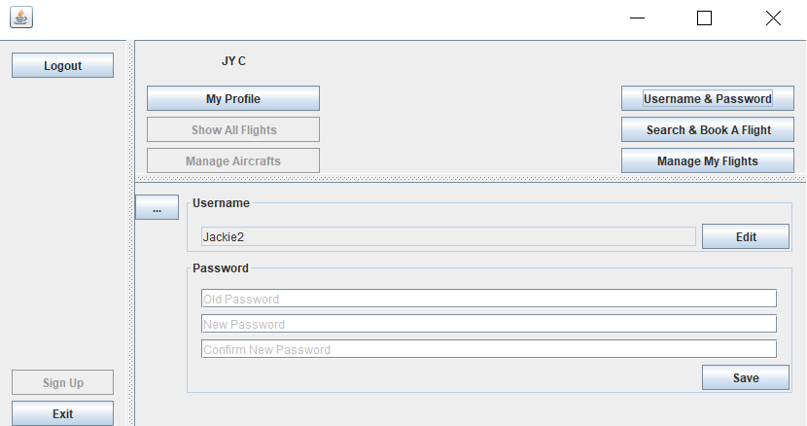

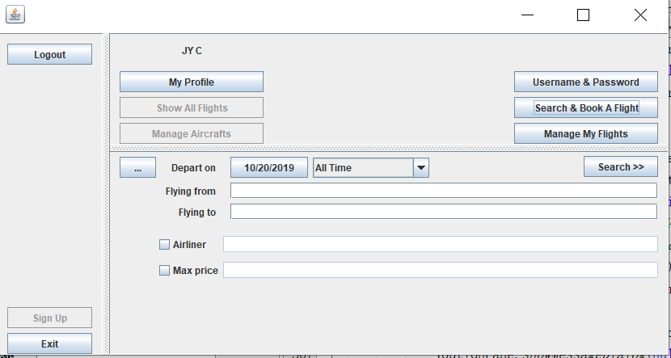

Customers can search and book a flight like following.

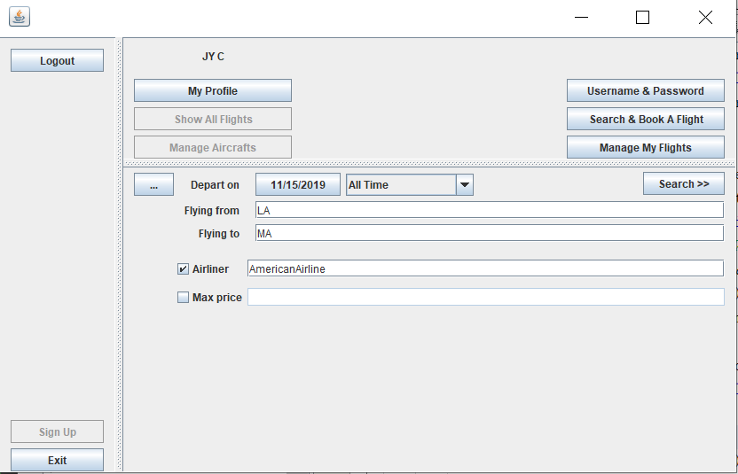

Customers can choose the checkboxes if they want.

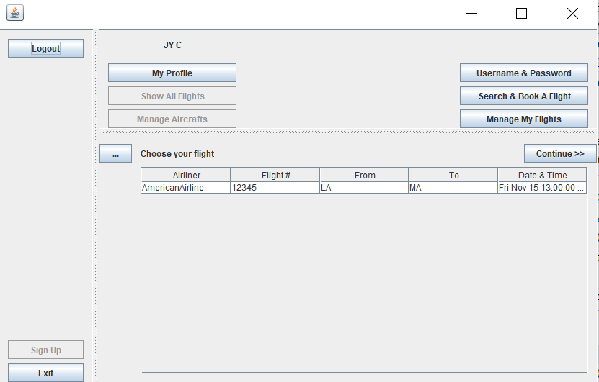

Select one flight and continue.

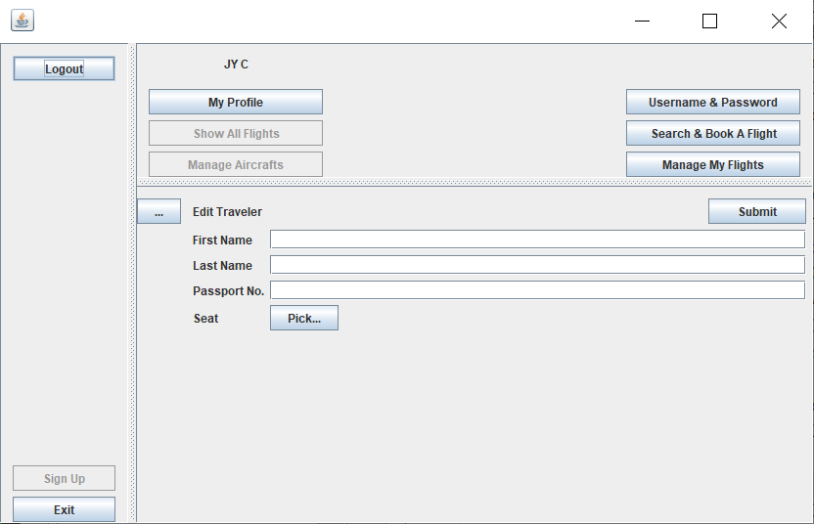

Then you can offer traveler’s information to book a ticket.

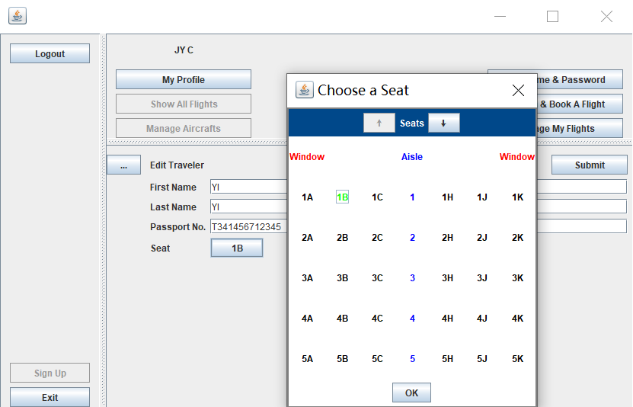

You can choose a seat.

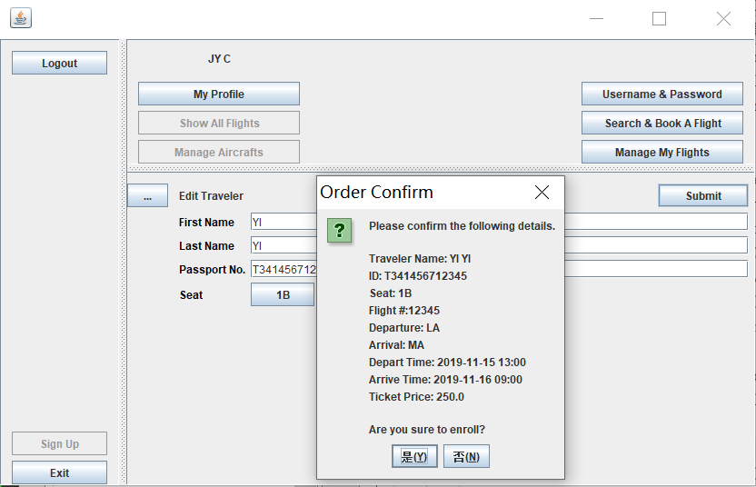

Order confirmation.

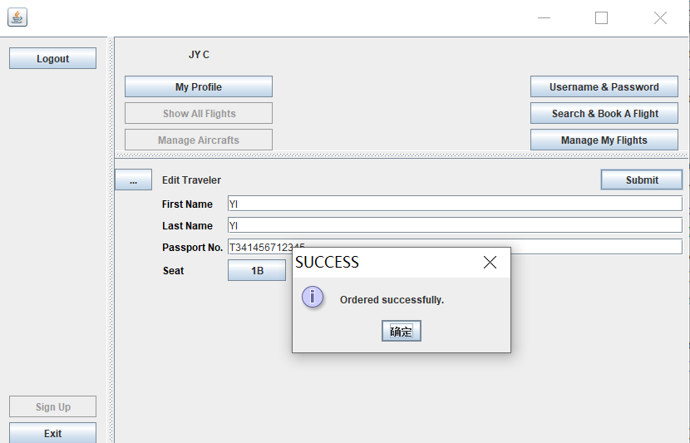

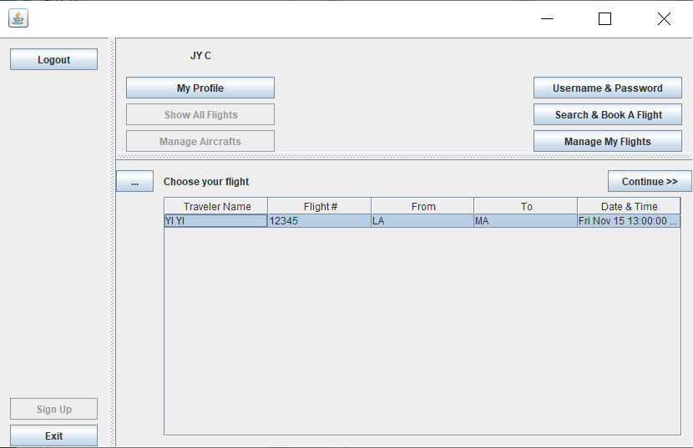

You can manage your flight by clicking continue.

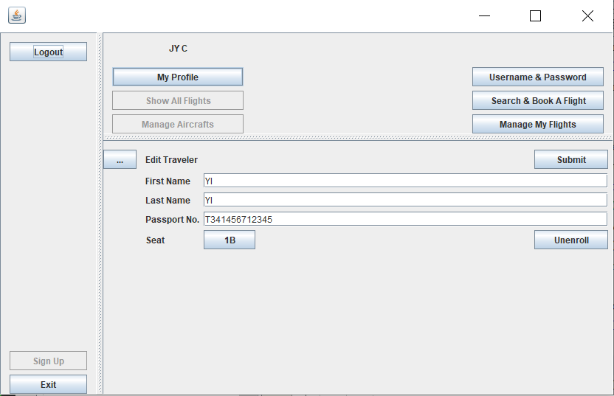

③ As an administrator:

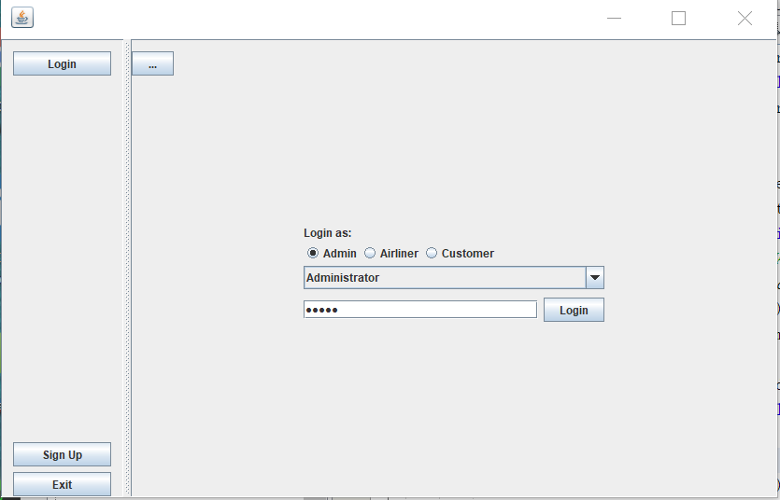

Administrator is a default account.

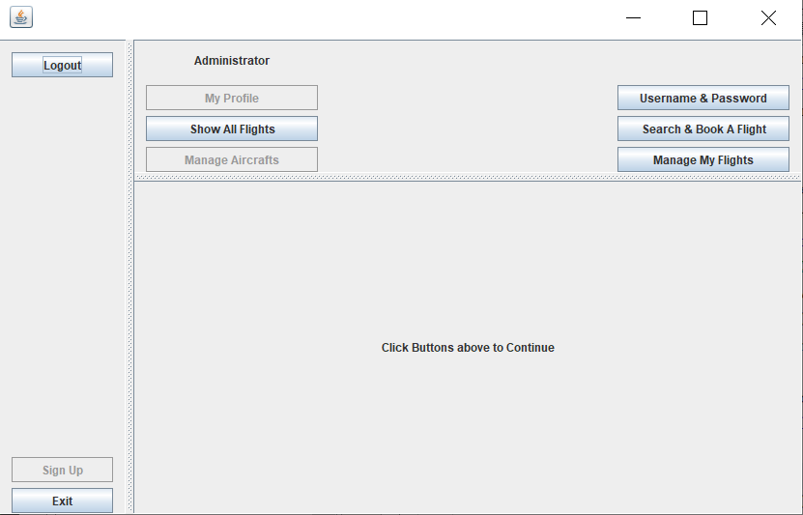

Administrator can see all flights, change username and password, search and book a flight, and manage flights.

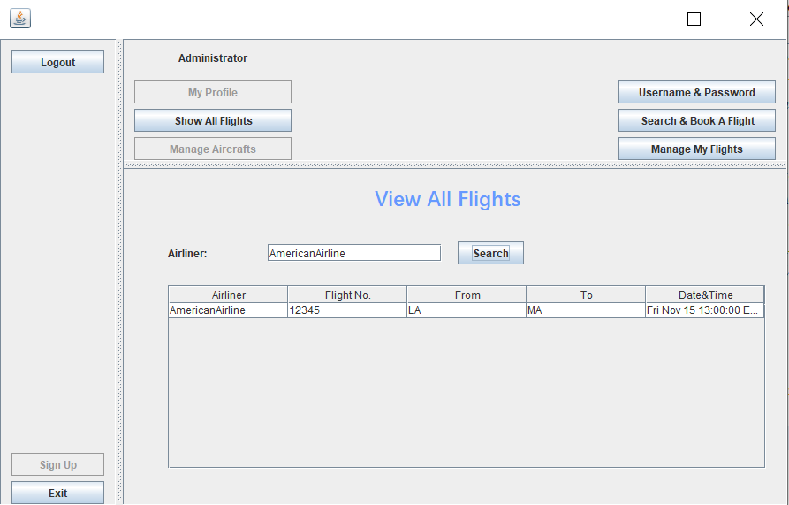

View all flights by searching a specific airliner.

Rest three buttons have the same function of customer’s.

1. Exit the panel.